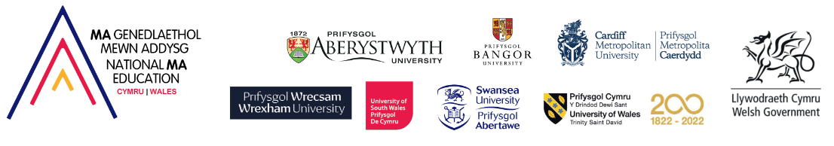

Frequently Asked Questions:

1. Who is the EdD programme intended for?
The National EdD (Wales) is a part-time Doctor of Education programme co-delivered by Aberystwyth University, Bangor University, and Cardiff Metropolitan University. It is designed for educators who have completed the National MA Education (Wales) or other equivalent Masters degrees.
Equivalency will need to be demonstrated for non-National MA graduates.

2. How is the programme structured?
Phase 1 (Year 1): A taught 60-credit module titled "Planning for Doctoral Study and Thesis Preparation," This module will be delivered synchronously online through five taught sessions and five Community of Practice meetings (January to June 2027) and an on-campus residential EdD Summer School (July 2027). All sessions including the Summer School are compulsory.
Phase 2 (Years 2-6): Students will undertake empirical research, resulting in a doctoral-level thesis with support from academic supervisors.

3. How do I apply for the National EdD (Wales)?
To apply, you must:
Apply via the MS Forms Link
- Addysg Cenedlaethol (Cymru) 26-27 – Fill in form (To complete in Welsh)
- National EdD (Wales) 2026 – Fill in form (To complete in English)
- Submit evidence of your Masters degree (classification and dissertation title).
- Provide a letter of support from your line manager confirming that they will support you to attend the compulsory Summer School in July
- Submit a 1000-word abstract including:
Reasons for pursuing the National EdD (Wales).
Proposed title with an area of investigation or research study.
Proposed research question (s)
Rationale, background or context for the study: what research has already been done in this area?
Proposed research design/methodology
Why applicants feel that this research is important.
Reference list (this will not count as part of 1000 words)

4. What funding options are available?
Applicants can seek funding through:
Welsh Government (please see eligibility criteria above)
Institutional Funding
Self-Funding

5. Will there be any in-person components?
Yes, the programme includes a compulsory on-campus Nat EdD Summer School, which will take place in July 2027, at Cardiff Metropolitan University. Applicants will need to evidence support from their Headteacher/line manager prior to application.

6. How can I get more information?
For further questions, you can contact nationalmaeducation@cardiffmet.ac.uk.

7. What happens after I submit my application?
Applicants who meet the initial criteria will participate in an interview process. Following successful completion of the interview, you will be asked to register with the institution of your choice.

Closing date for January 2027 entry: 14th August 2026

